EX 4.

Pick one-one from the available sensors and actuators and find or create code that will display the sensed data on the PC.

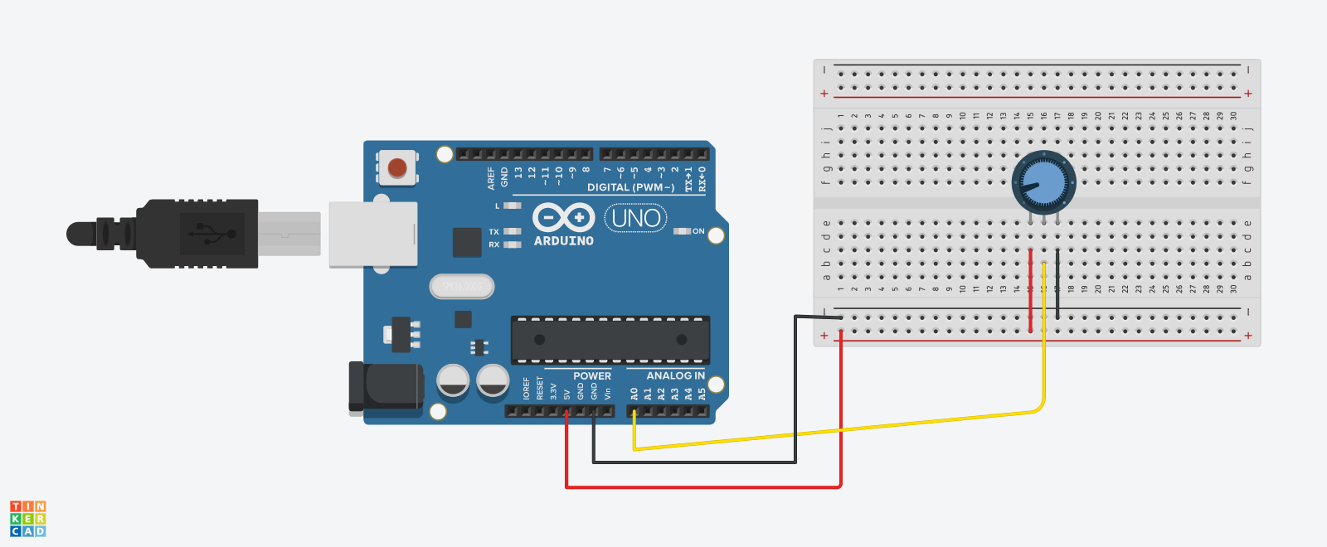

Code:

int pot=A0;

void setup()

{

Serial.begin(9600);

}

void loop()

{

int potvalue=analogRead(pot);

Serial.print("potvalue");

Serial.println(potvalue);

delay(10);

}

Output

Serial Monitor

6

6

6

439

452

464

559

4.1.

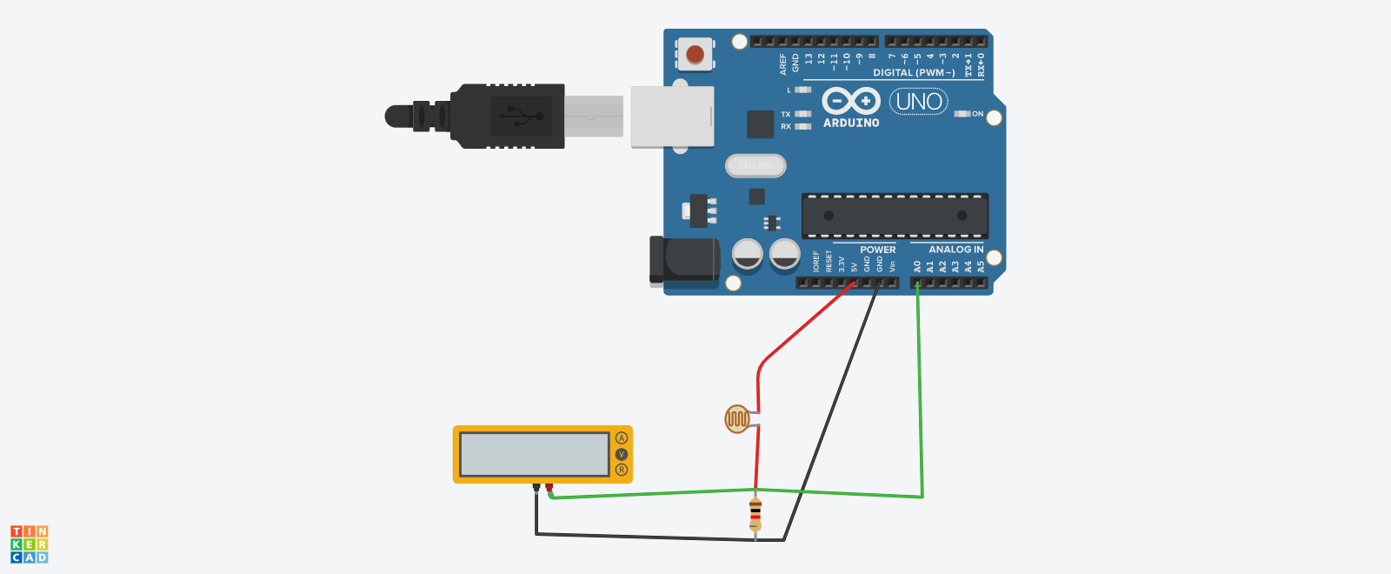

Code:

void setup()

{

pinMode(A0, INPUT);

Serial.begin(9600);

}

void loop()

{

int lightvalue=analogRead(A0);

Serial.println(lightvalue);

delay(1000);

}

Output:

6

6

6

6

6

6

6

6

118

517

517

607

607

607

607